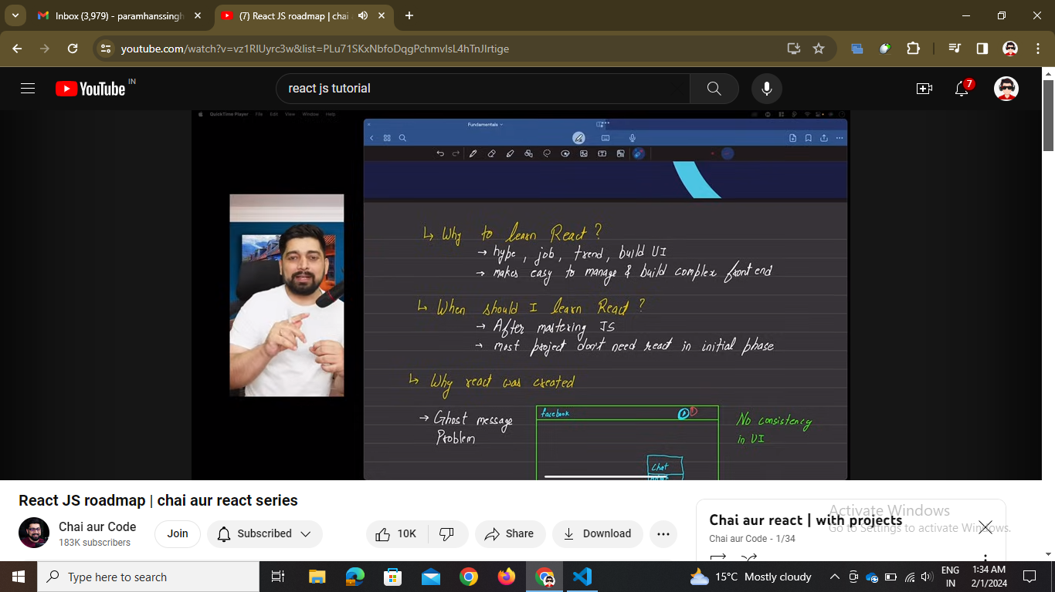

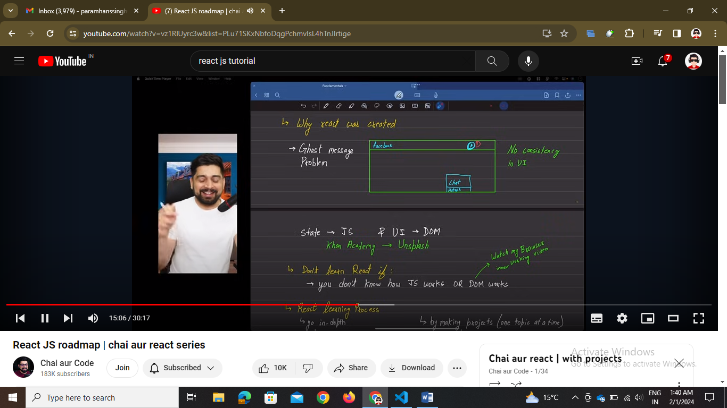

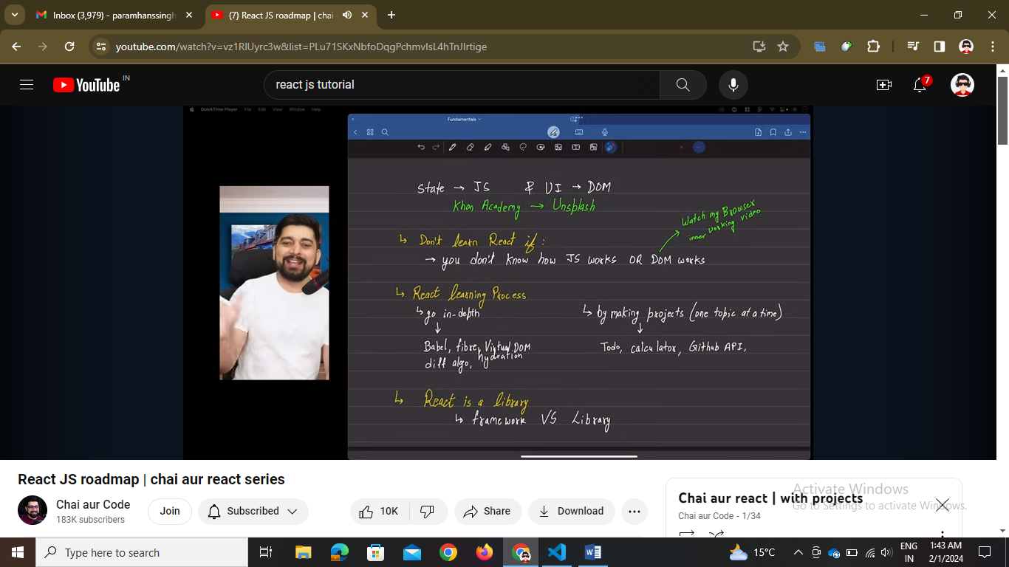

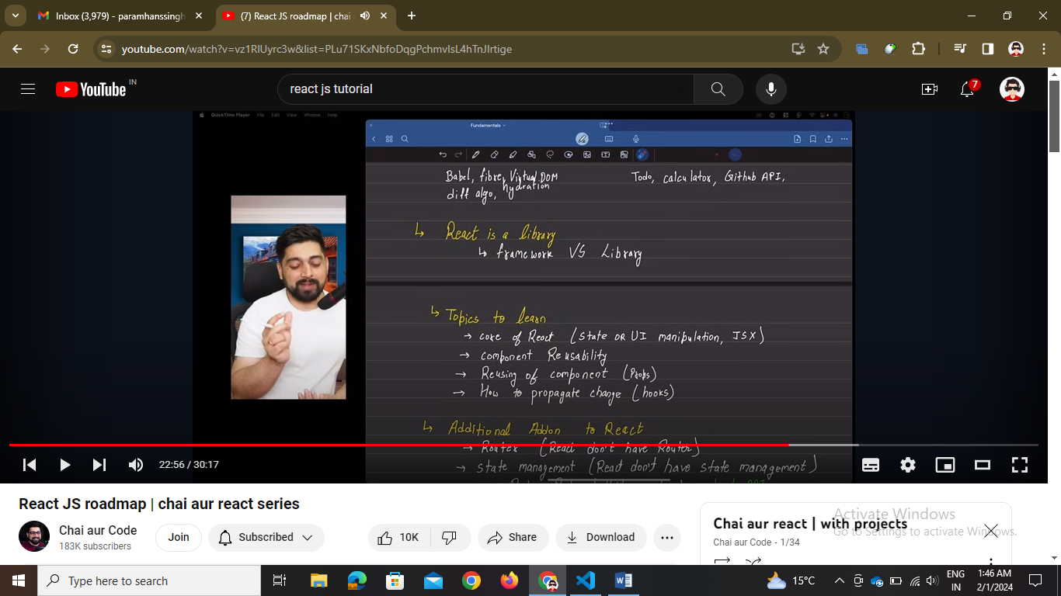

// react is for spa (Single page application) no reloading so we have different libraries for the react router and state management

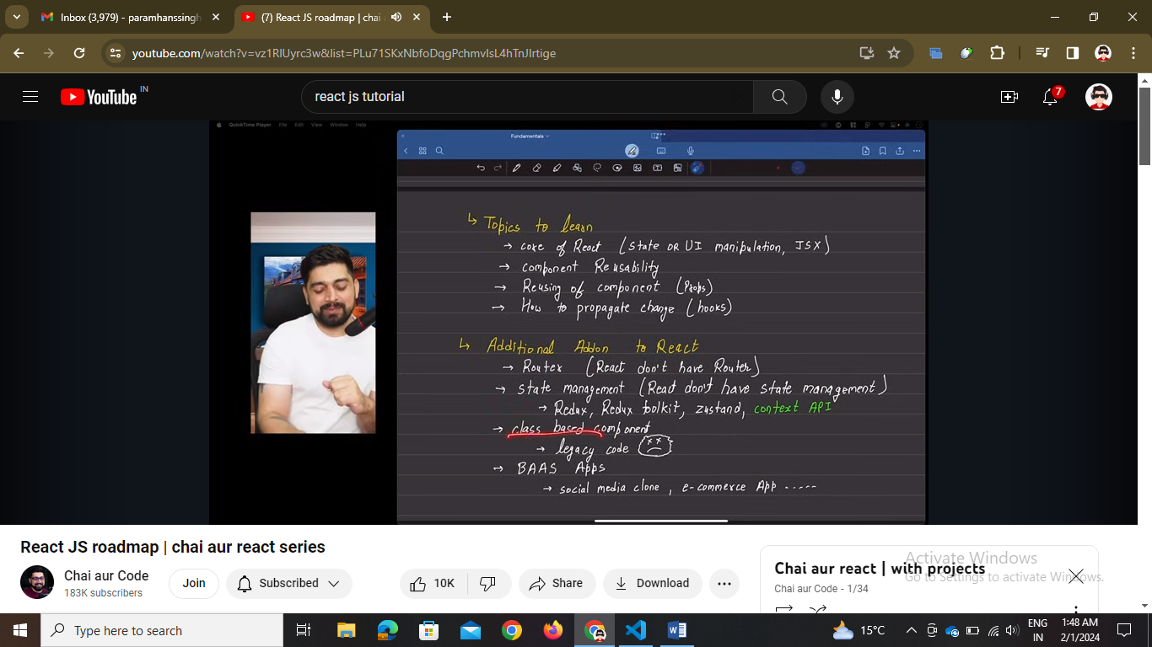

// backend as a service – BAAS 🡪 firebase, appwrite, superbase -🡪 u can use the service of backend directly.

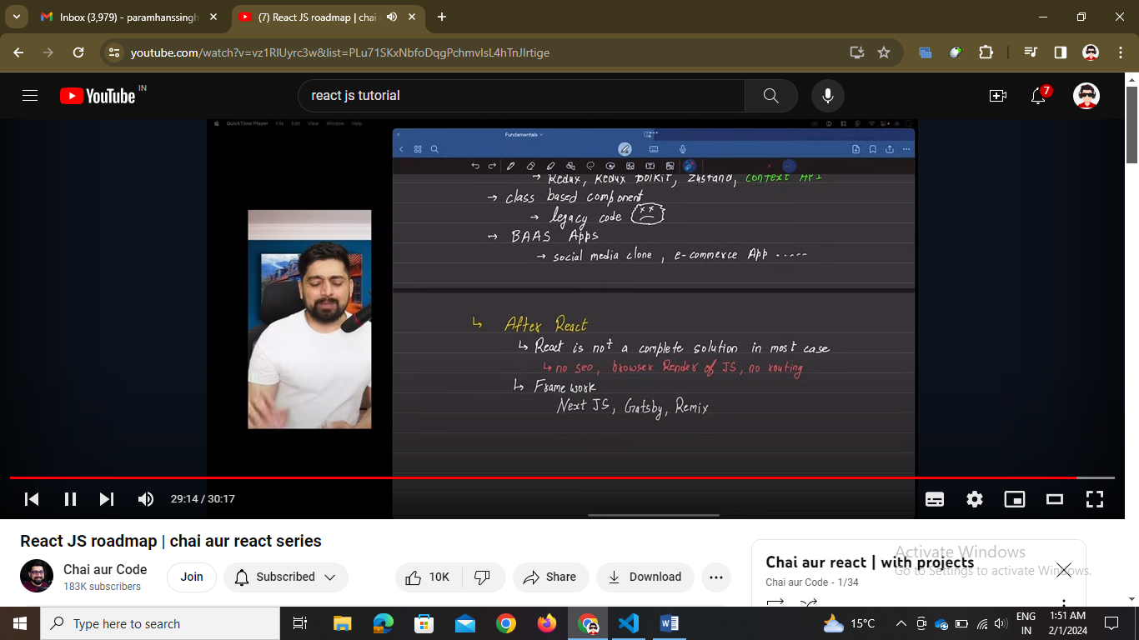

// next js mai backend and frontend dono hai